## **BUAD 5722 Big Data - Steps To Running Docker instance of Hadoop Services**

## Visit [https://gitlab.com/wmrepo/ bigdata](https://gitlab.com/wmrepo/%09bigdata)

* Click Download

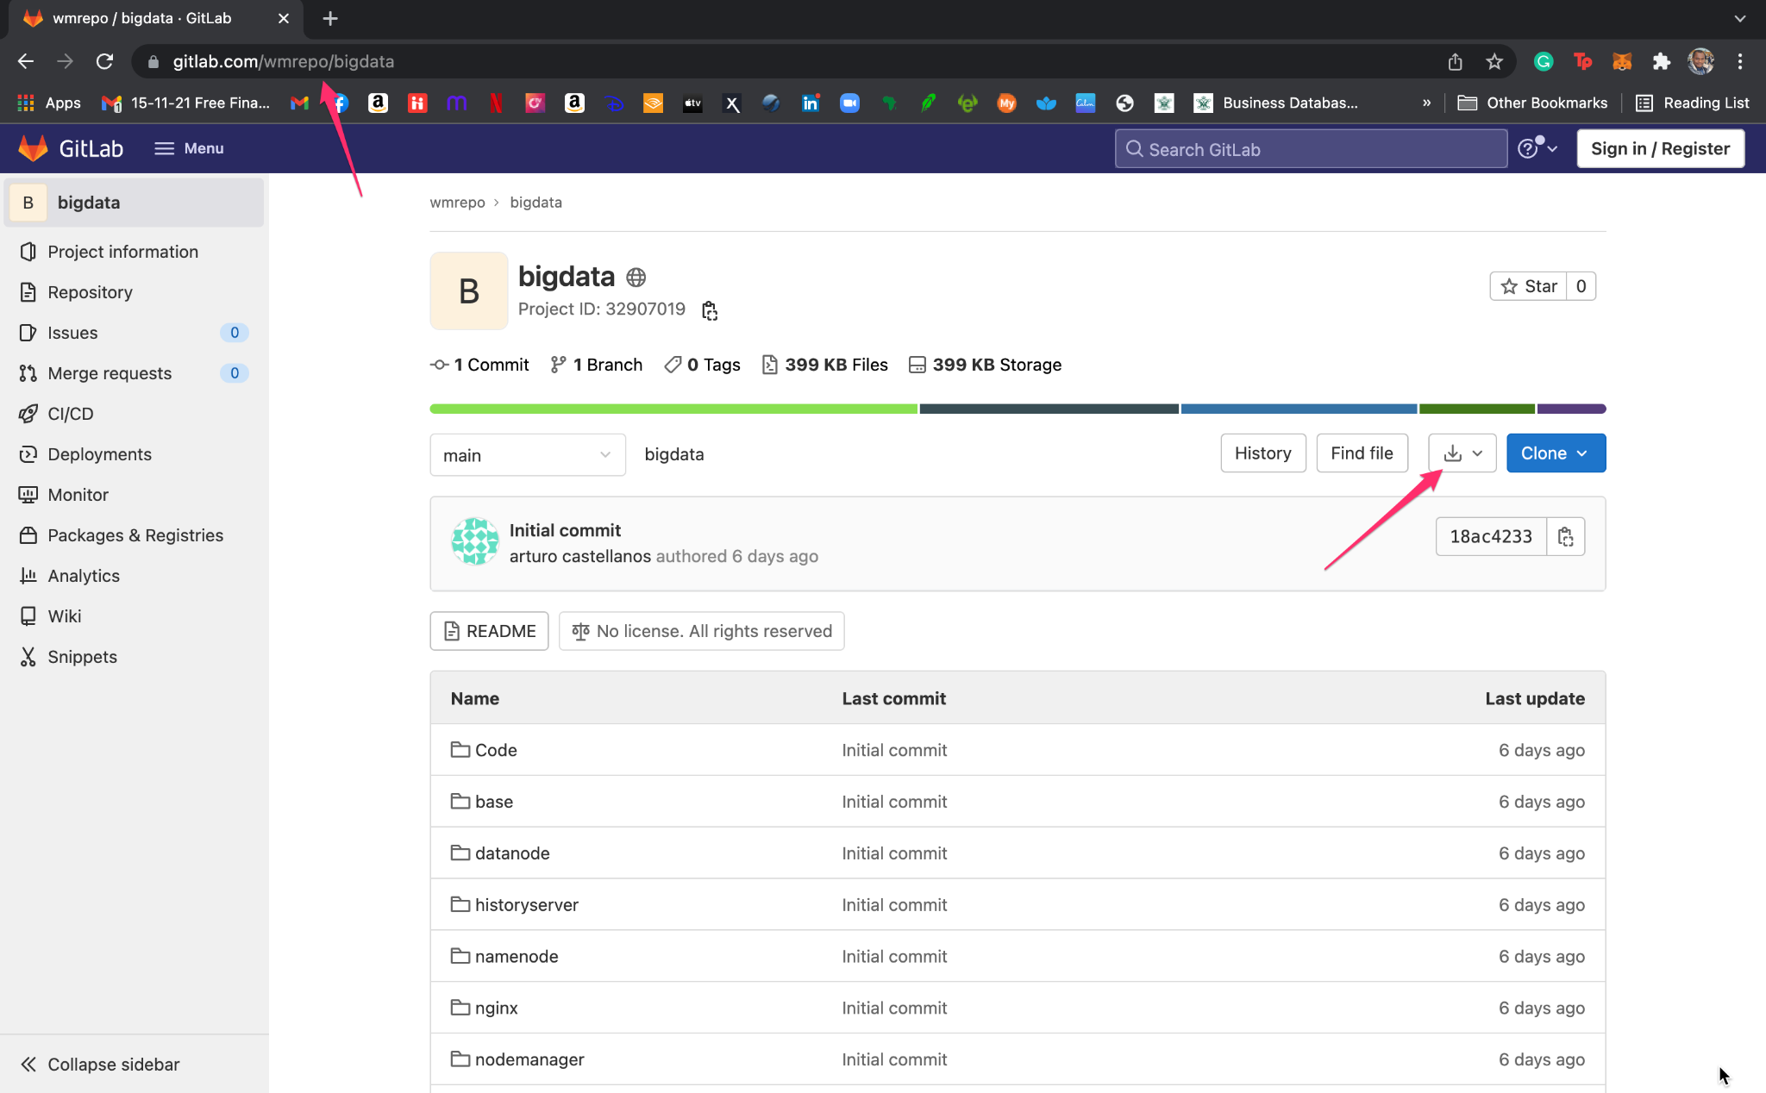

* Navigate to download path

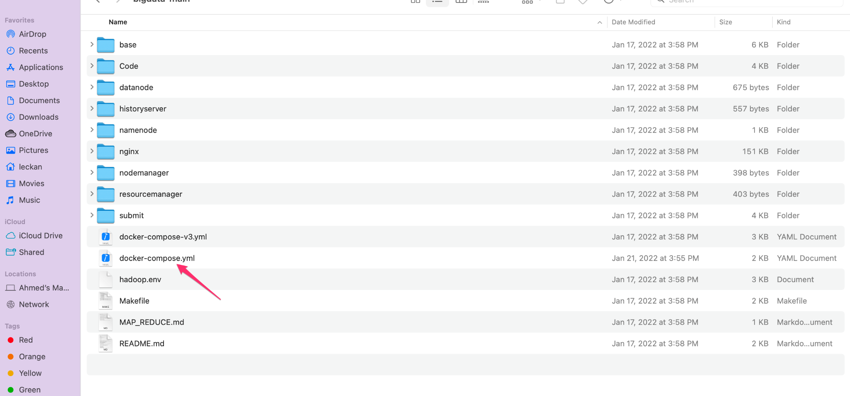

* Open docker-compose.yml in a text editor

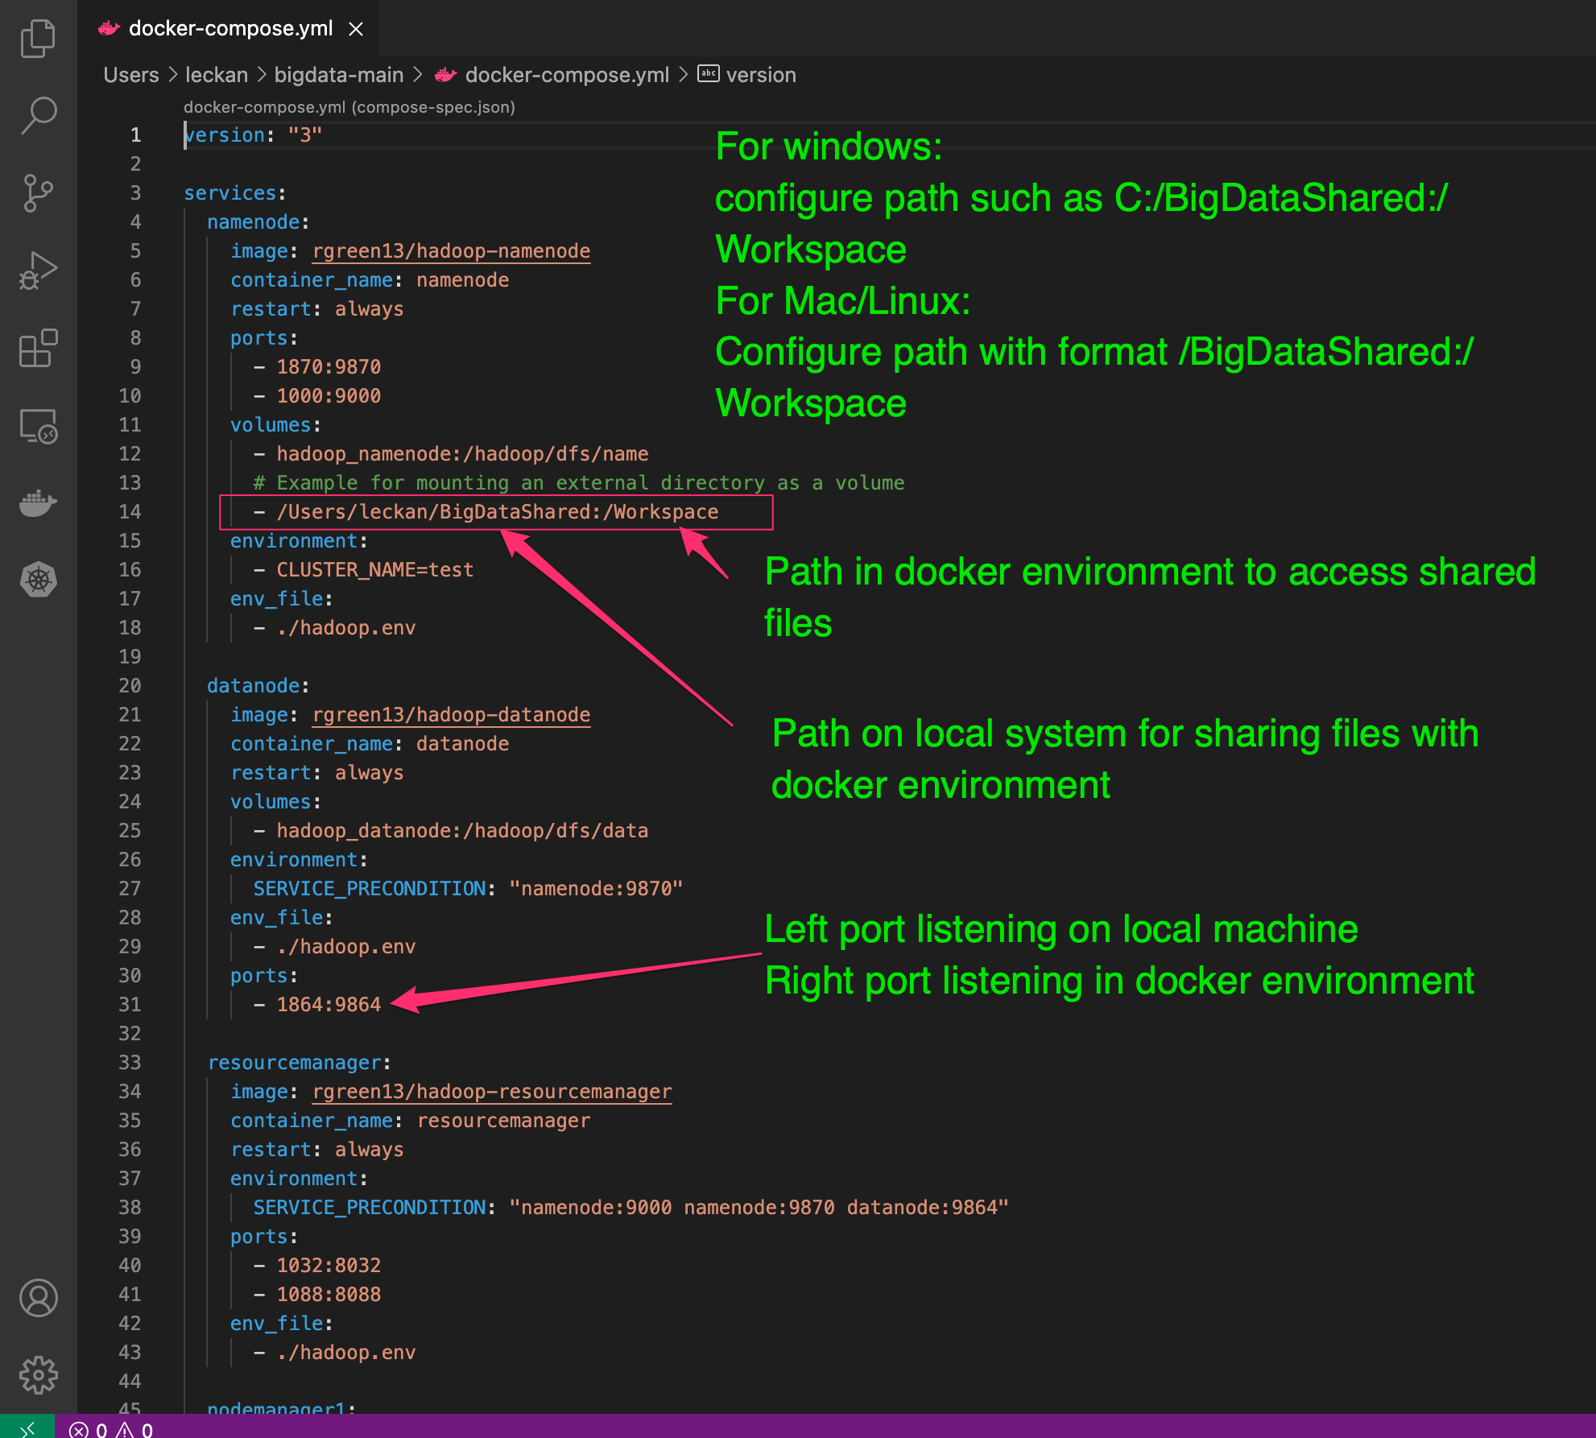

* Download and install Docker on local machine if not already installed
  + <https://docs.docker.com/desktop/>
* Launch Docker

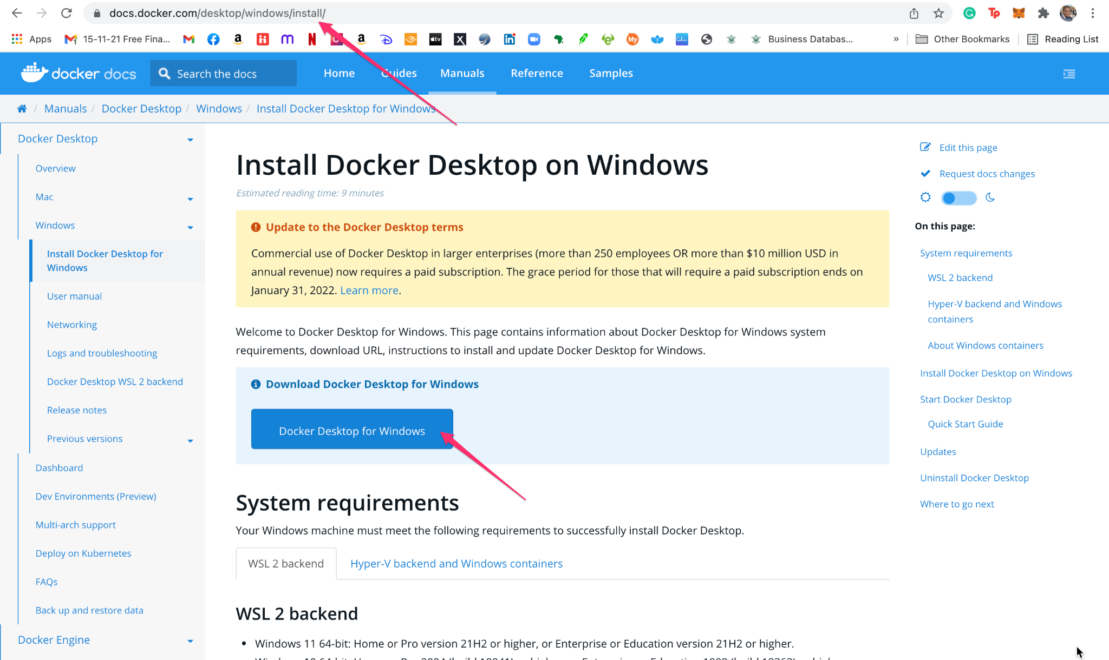

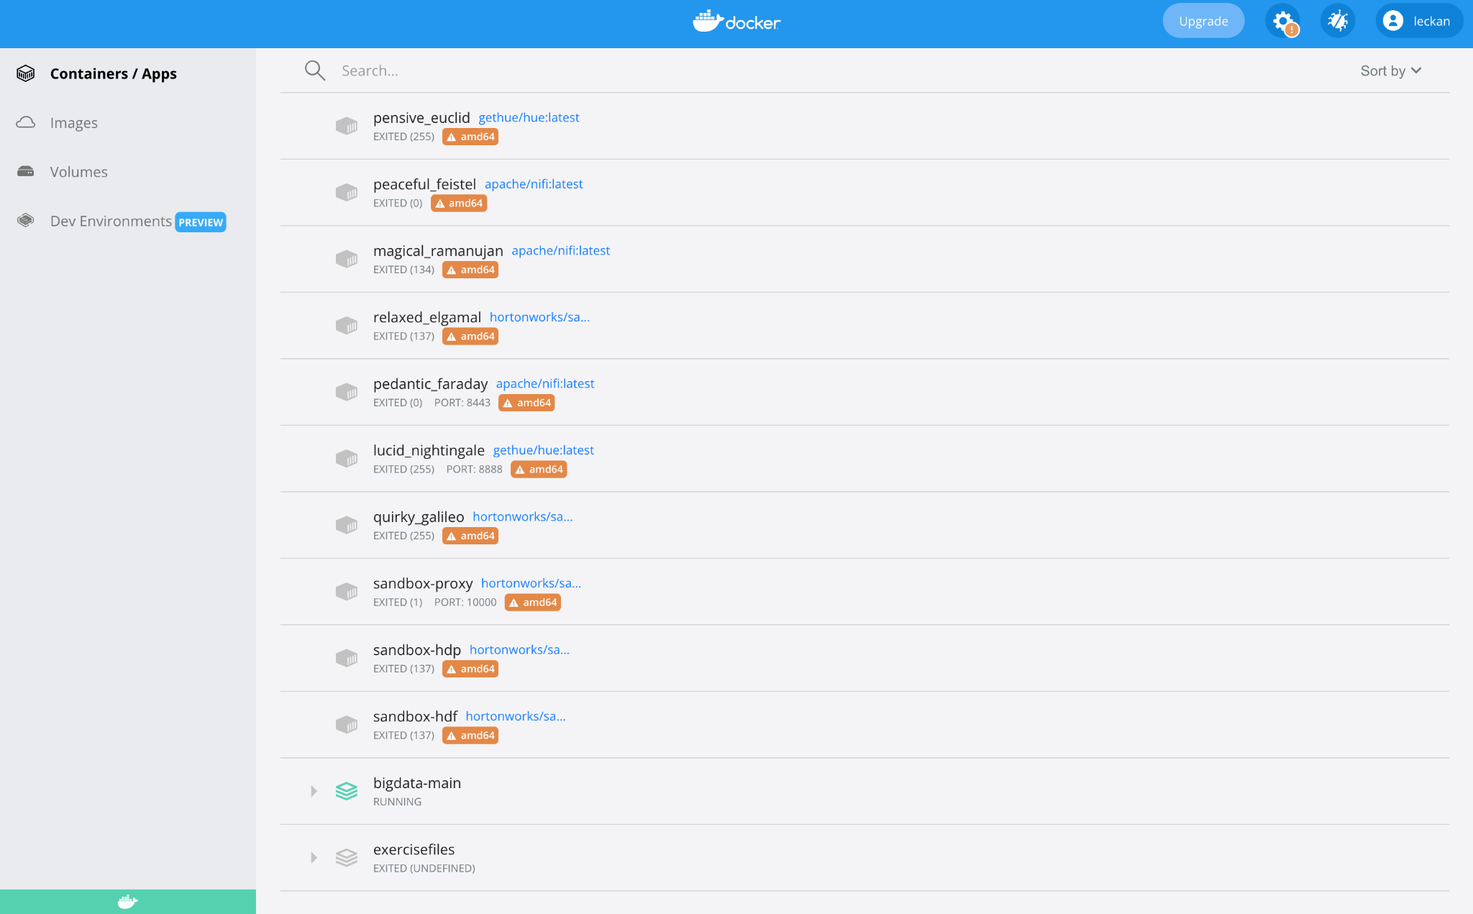

* Launch Bash or command prompt as admin (terminal for mac)
* Change directory to big data docker file path
* E.g cd C:/Users/leckan/bigdata-main
* Run the command below
  + docker-compose up

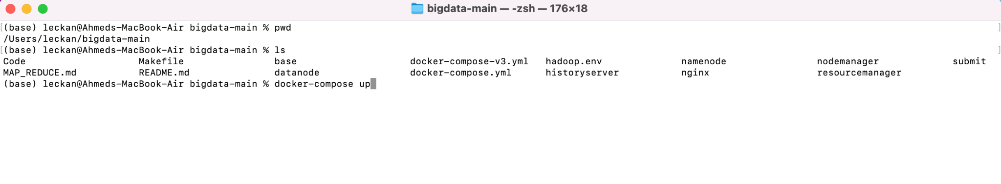

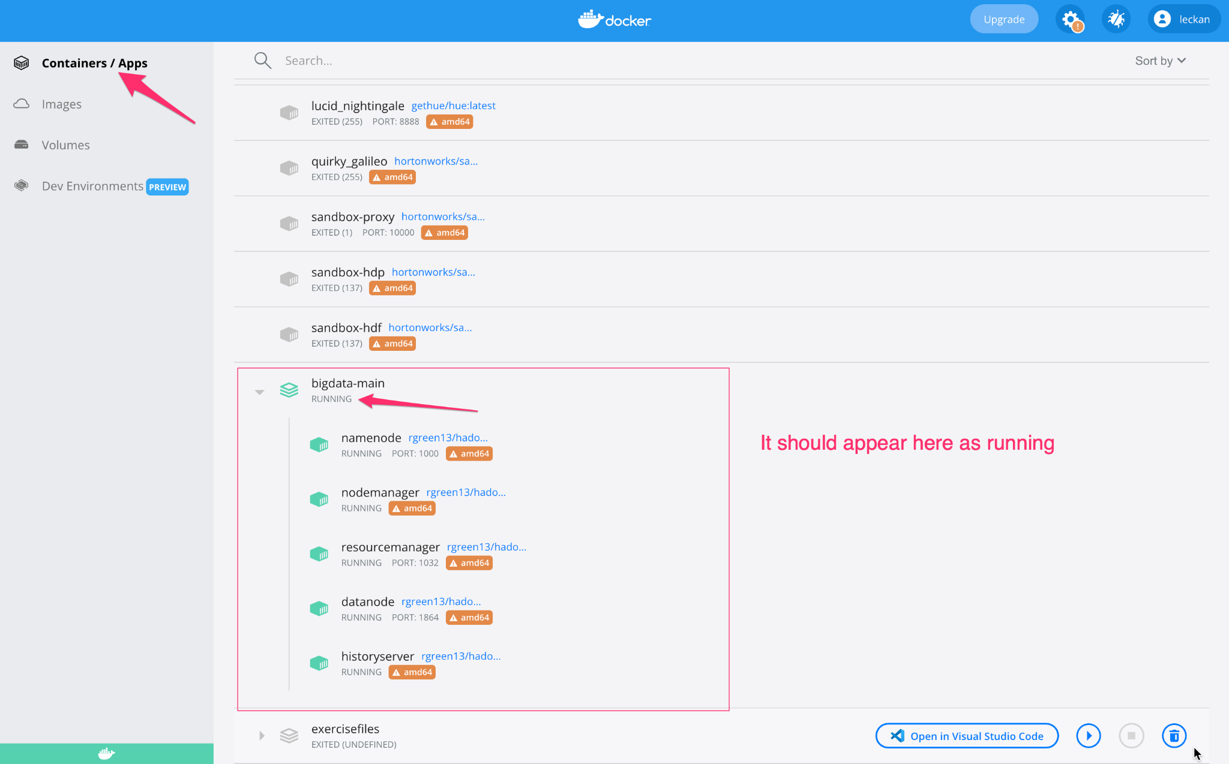

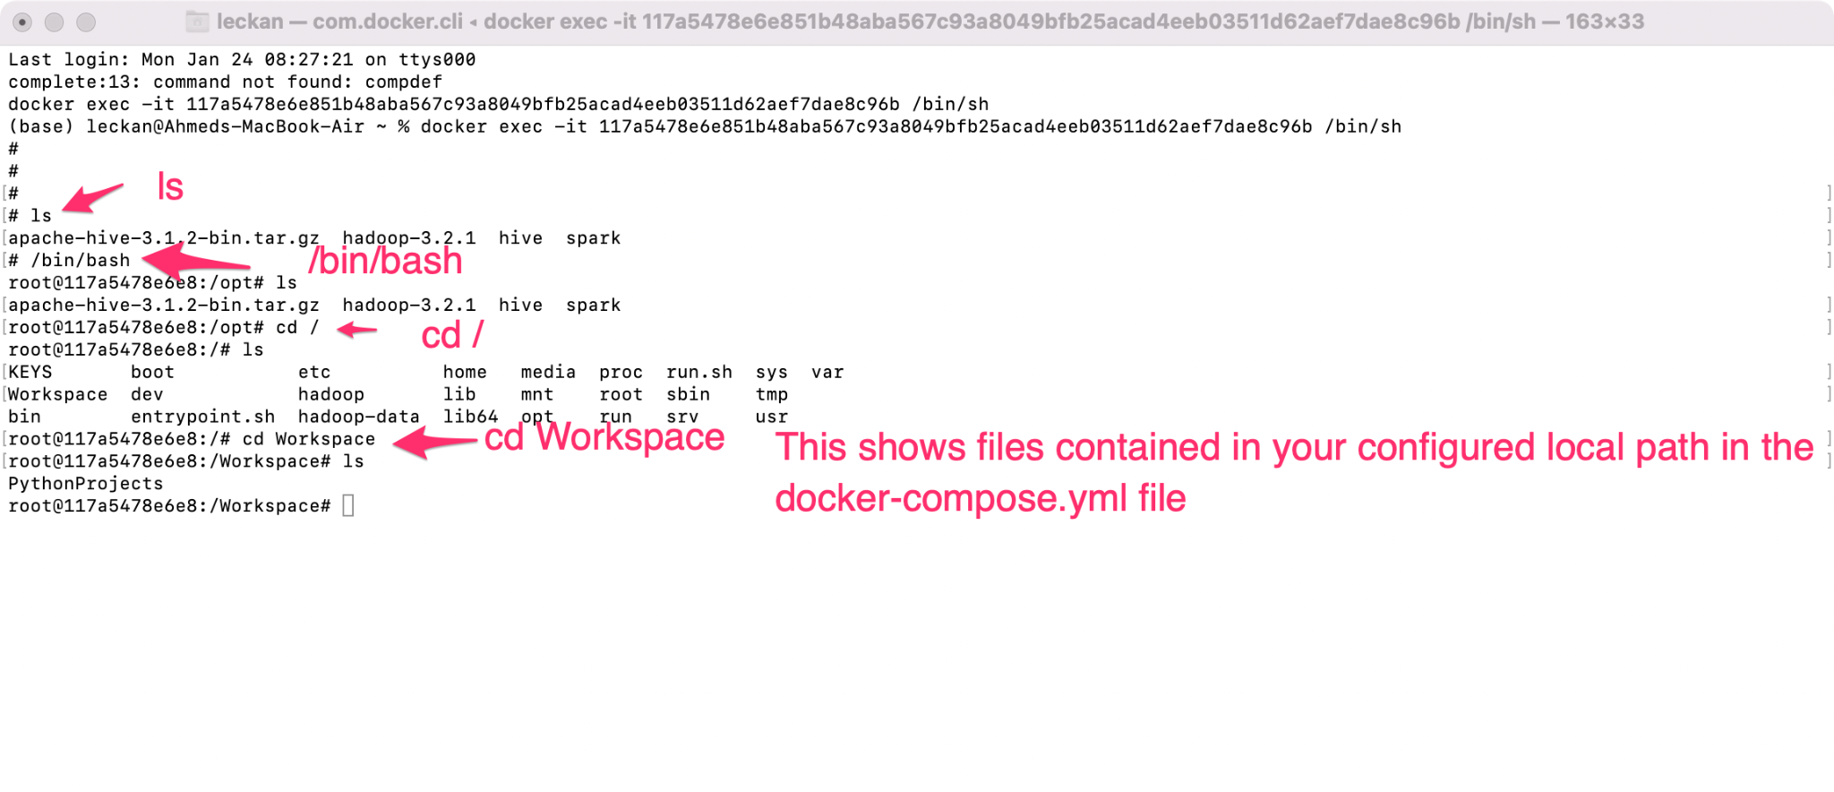

* You can stop the container from docker desktop app